# Test Document for Venue Registration/Login Service

|  |  |  |  |  |
| --- | --- | --- | --- | --- |
| Function Tested | Input | Expected Output | Test Output | Test Result |
| RegisterVenue()  This function returns a boolean which is true if a new venue is successfully registered, and false otherwise  ****** | Registering a new venue named Jet City. Username = JetCity, Password = JetPass (all the other required fields are provided as well) | true | Figure 1 | Passed |
| Registering the same venue (all the information unchanged) | false | Figure 2 | Passed |
| Registering the same venue (changing username and password only) | false | Figure 3 | Passed |
| Registering a venue by changing the name, username and password while keeping all the other values the same | true | Figure 4 | Passed |
| VenueLogin()  **********  This function returns the unique venue login key that is assigned to all the registered venues. If the username and password do not match the database records, the return is 0  ******* | Logging in with JetCity username and JetPass password | Integer greater than 0 | Figure 5 | Passed |
| Logging in with JetCity1 username and JetPass1 password | Integer that is not 0 and not the same as the previous case tested | Figure 6 | Passed |
| Logging in with wrong (Jetpass1 instead of JetPass1) password | 0 | Figure 7 | Passed |

Figure 1. Register new venue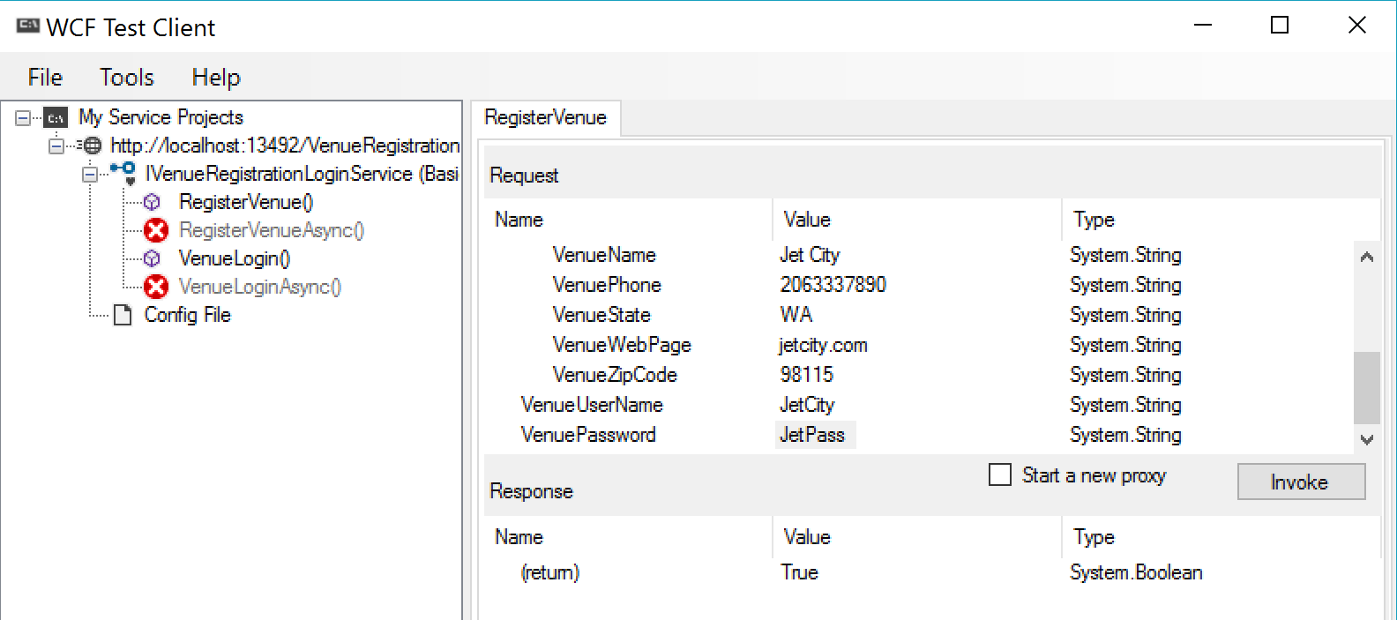

Figure 2. Register the same venue (all values the same)

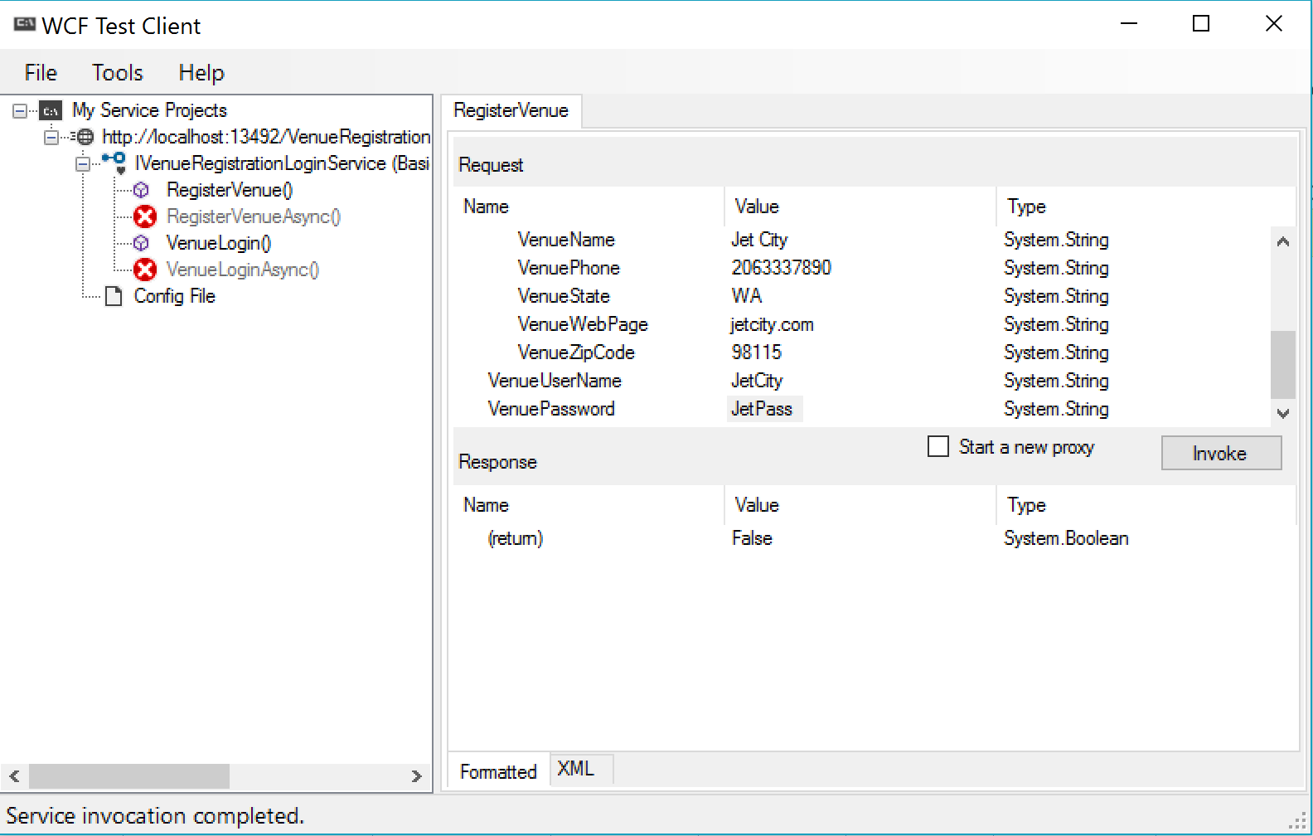

Figure 3. Only change the username and password

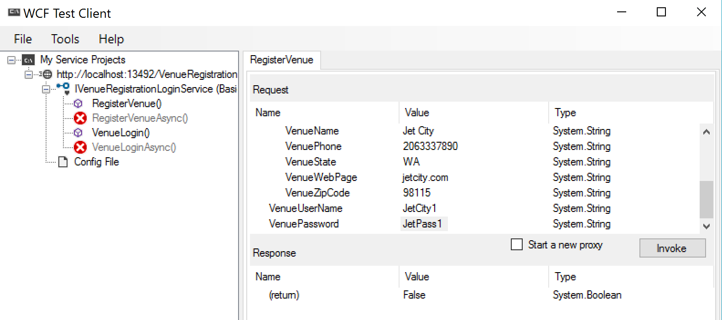

Figure 4. Change the name, the username and the password

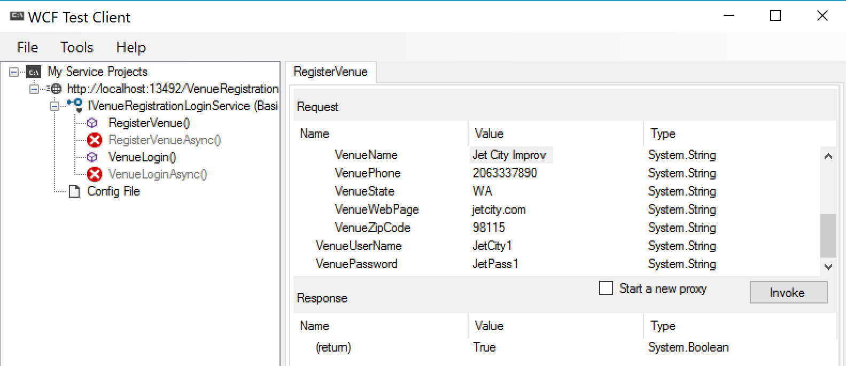

Figure 5. Venue Login

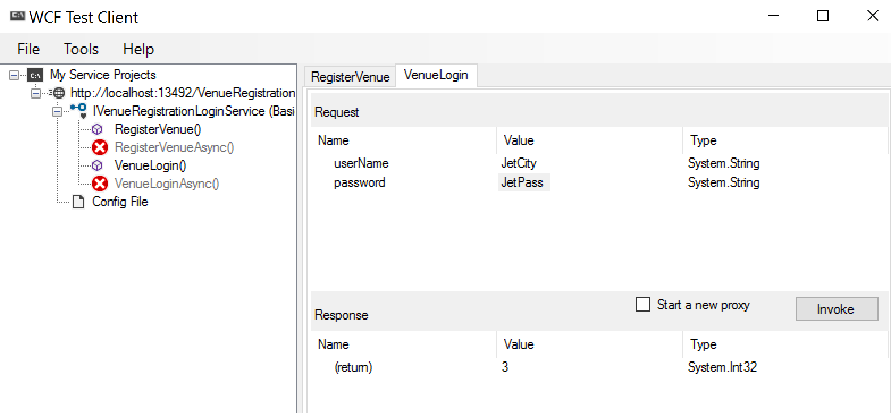

Figure 6. Different venue login (different key returned)

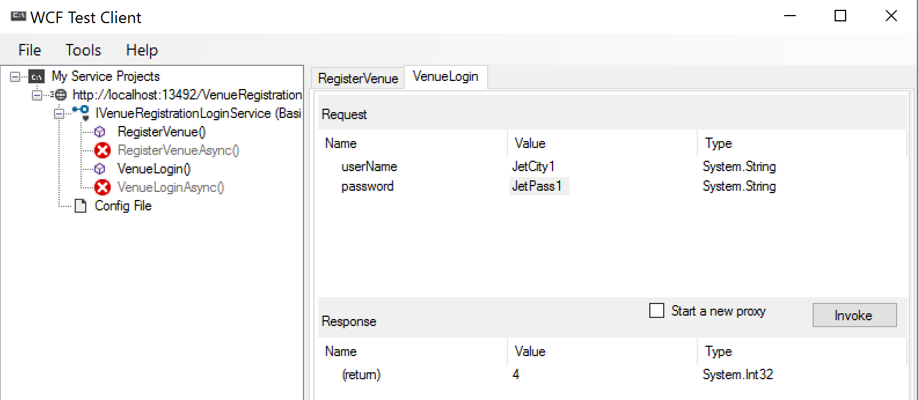

Figure 7. Wrong password login

